Butterfield’s Overland Mail Company Employee Silas St. John
and
His Gravestone in the San Diego Cemetery

By
Gerald T. Ahnert
©2019

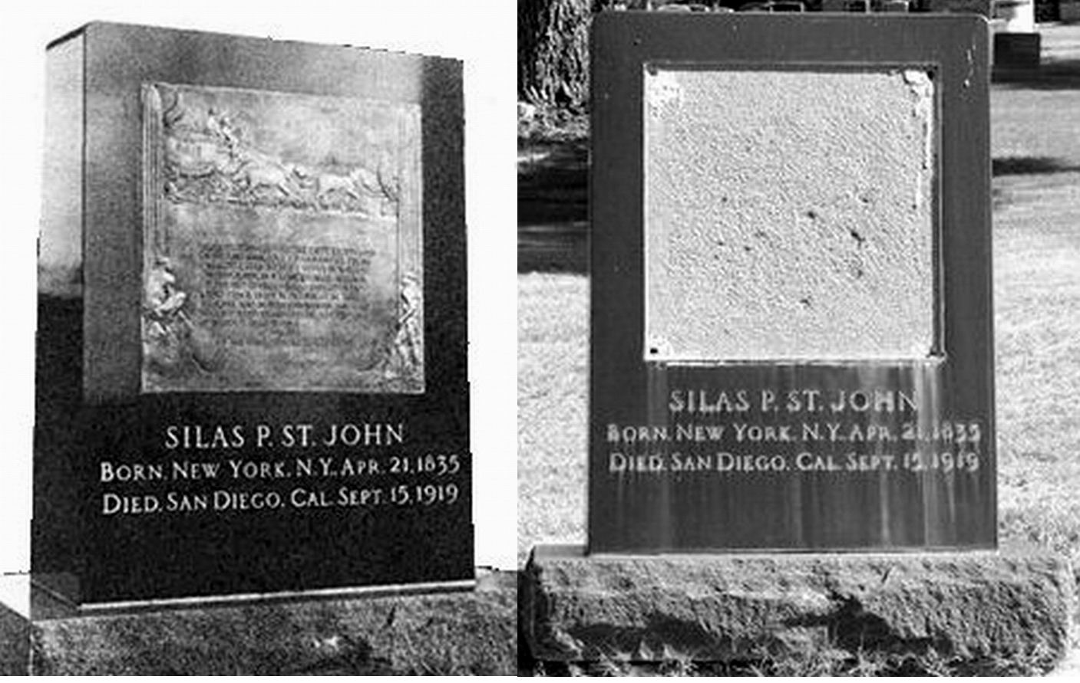

The Silas St. John Gravestone in the San Diego Cemetery

Silas St. John’s gravestone before and after the bronze plaque was stolen. The plaque has not been remounted as most of the inscription has been determined not to be correct. The plaque was later recovered and is now in possession of the San Diego History Center.

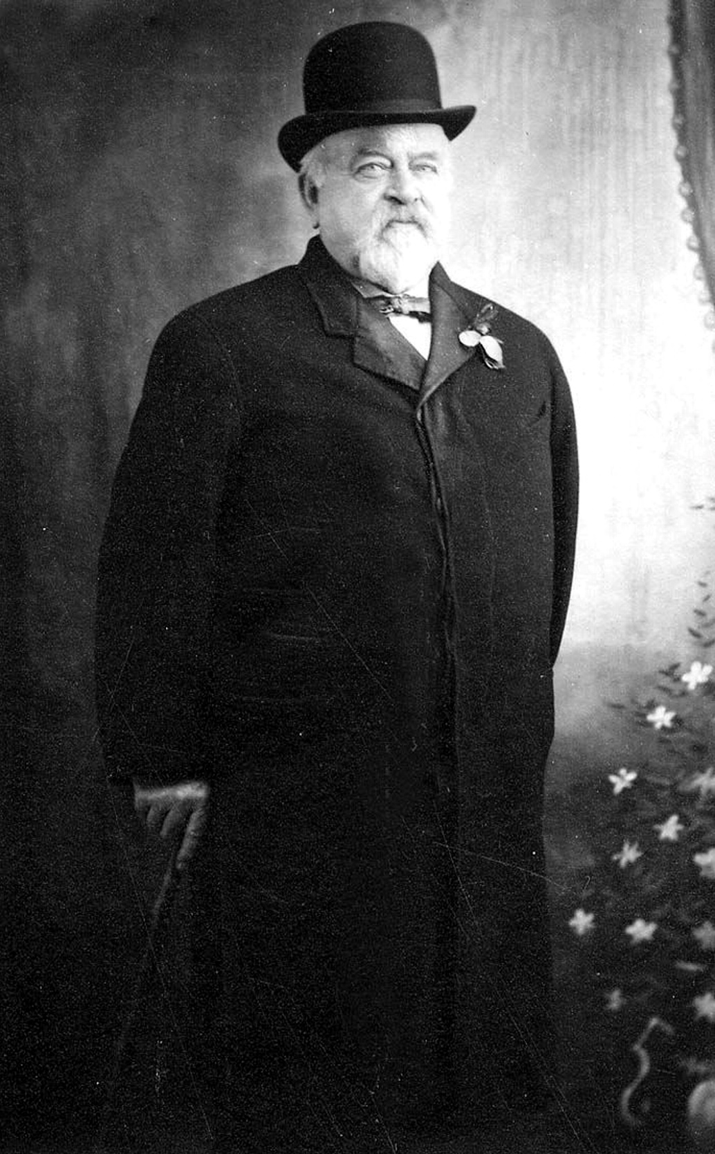

Silas St. John in 1908
Courtesy: Prescott Pioneers Museum

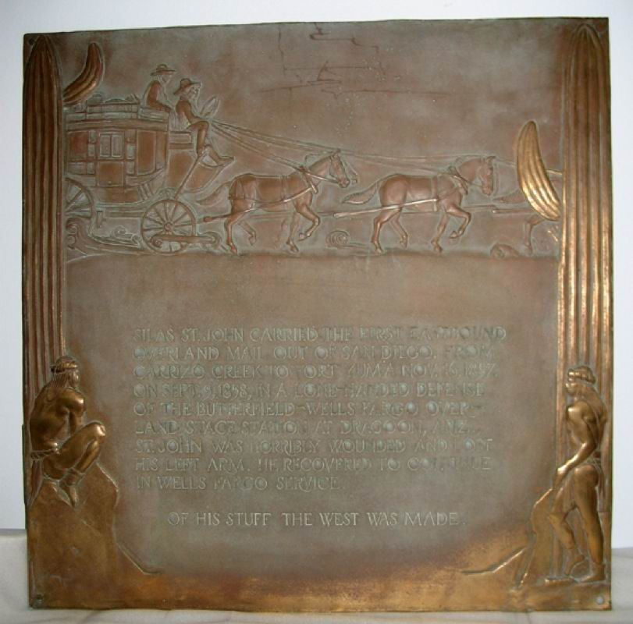

On the plaque is this incorrect wording:

“Silas St. John carried the first eastbound
Overland Mail out of San Diego, from
Carrizo Creek to Fort Yuma Nov. 16, 1857.
On Sept. 9, 1858, in a lone-handed defense
Of the Butterfield-Wells Fargo Over-
Land stage station at Dragoon, Ariz.,
St. John was horribly wounded and lost
his left arm, he recovered to continue
in Wells Fargo Service.
Of his stuff the West was made.”
Very little is true. According to San Antonio and San Diego Mail Line Superintendent I. C. Woods, the first mail going east out of San Diego was not on November 16, 1857, but on August 9, 1857. It should also be noted that in the thirty-six-page report from The Postmaster General, giving a complete chronological order of the six-year Butterfield contract No. 12,578 and all its changes, which extended from September 1858 to September 1864, that nowhere is the name of Wells Fargo & Co. to be seen. The Overland Mail Company was a stock-holding company by individuals only and was detailed in this important document shown below, concerning the ownership of the Overland Mail Company during the six-year contract.

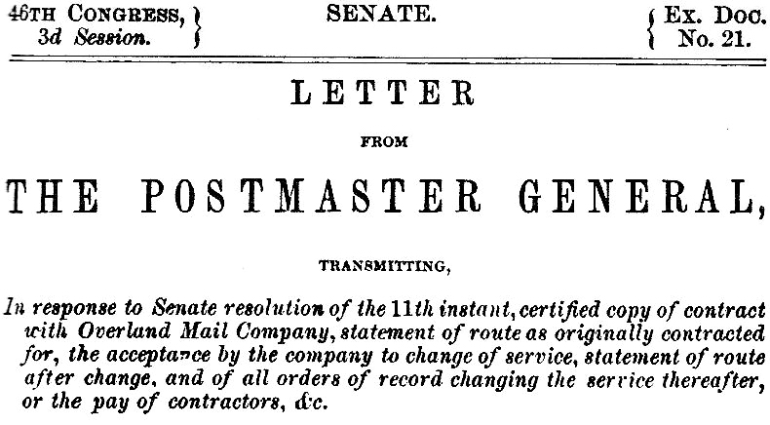

Recognition of the misinformation on the plaque, and the reason that it was not remounted on the gravestone, was given by Wells Fargo & Co. blog site historian Alan Peterson. On their site, under the title of “The Homecoming of Silas St. John,” about the stolen plaque was his statement:

“Problem: St. John was never a Wells Fargo employee—even though the bronze says he was.”

Silas St. John was only an employee of Butterfield’s Overland Mail Company from August 1858 to March 1861, as Arizona’s Dragoon Springs Stage Station was never a Wells Fargo & Co. station. In March 1861, he returned to New York City where he worked for Adams Express Co.
If a new plaque is mounted on the gravestone, this is a suggestion for the new wording:

Silas St. John carried the first eastbound mail out of San Diego for the San Antonio and San Diego Mail Line August 1857, from Carrizo Creek to Fort Yuma. On September 9, 1858, while an employee of John Butterfield’s Overland Mail Company, in a lone-handed defense of the Dragoon Springs Stage Station in Arizona, St. John was horribly wounded and lost his left arm. He recovered to continue in the service of the Overland Mail Company. In an interview he stated:
“Do you think I was born to be killed?”

Of his stuff the West was made

The quote “Do you think I was born to be killed” appeared in an interview with Silas published in the: Public Ledger, Memphis, Tennessee, June 13, 1878, “A Charmed Life.”

Silas St. John Chronological History

1835 April 21: Born in New York City, Essex St.
1854: Arrives in the southwest.
1857, August 9: First mail from San Diego going east. In this reference Isaiah Churchill Woods stated in his June 20 (1857) entry: “The first mail for San Diego left San Diego on the 9th of August [1857].” In the following reference Silas St. John gives some details for the first mail from San Diego: The establishment of the trans-continental mail service upon the Overland Stage Route, Sharlot Hall Museum Library & Archives, Prescott, Arizona. Note: The document, by Silas St. John, originated sometime after 1900. Since there is a primary source for the date of the first mail out of San Diego (see Woods report above), Silas probably had a lapse of memory in his old age for giving the date of the first mail as “…October 1857.” In this reference Silas states: “Charley Youmans was the first rider - leaving San Diego at 12 midday sharp, amid booming of one canon and fusillade of guns and pistols. He had two remounts, reached Cariso [Carrizo] Creek via Warner’s ranch at 8 P. M. Here the mail was taken by Silas St. John – accompanied by Charles [James E.] Mason to the next Station, Jaeger’s Ferry at Ft. Yuma, in 32 hours, without a remount.”
1858 August-September: Building stations for John Butterfield’s Overland Mail Company in eastern Arizona including Dragoon Springs Stage Station. September 9: He survives massacre at Dragoon Springs Stage Station. This article gives a summary of the massacre.

The New York Reformer (Watertown, New York)
November 4, 1858

Particulars of the Murder of Mr. James Burr and Companions

The last hope that there might be an error or falsehood in the first report of the massacre of our old fellow townsman, Mr. James Burr, and his companions, at Dragoon Springs has been dispelled by a letter from William Buckley, one of the superintendents of the overland mail company, to his father. The details of the horrid murder equal in atrocity anything we read in the annals of crime. Mr. B. writes from Tucson, seventy-five miles from Dragoon Springs, September 14, five days after the murder. We copy from his letter:

"Uncle James, Mr. St. John, Mr. Cunningham and Mr. Laing, together with three Mexicans in our employ, were stationed at that place, [Dragoon Springs.] Everything had gone on well. I had not learned of any trouble between the men. I had eight mules with quite a large amount of property at the place. The murder was committed by the three Mexicans. Mr. Laing is undoubtedly dead before this. Mr. St. John is wounded, but I think with good care he will recover. The murder was committed in order to steal the property, as I had quite a large amount there. Uncle James was lying outside the corral when he was found, which was on Sunday morning. The murder was committed on Wednesday night. He lay in his blankets, with his head on one side all broken in. He had been killed with a stone hammer, and from all appearances he was struck two blows. He undoubtedly died without a struggle, from his appearance and position when found. Mr. Colwell and another man I had sent up to Dragoon Springs arrived there Sunday morning. Soon after the stage came up with Lieutenant Mowry, Colonel Leach, and several other passengers. Immediately on their arrival they buried uncle James and attended to the wants of the wounded men. They had nothing to eat or drink from Wednesday night to Sunday morning, being unable to move from the corral. Everything was done for them that men could do."

1859, January 25: In Washington, DC, gives talk to Congress.
1861-1880: After the Overland Mail Company contract transferred to Central Overland Trail March 1861, he takes job with Adams Express in New York City.
1864: Living at 59 Broadway, New York City, according to Civil War registration.
1911 February: Appointed Assistant Superintendent of Pioneer Home in Prescott, Arizona.
1914: Purchases house in San Diego, California, at 4720 Kensington Drive.
1919, September 15: Dies in San Diego, California.

As can be seen by the “Silas St. John Chronological History,” Silas St. John was never employed by Wells Fargo & Co.
Kirby Sanders was assigned the Congressional authority to compile the known references for the Bill in Congress to designate the Butterfield Trail a National Historic Trail. Here is his description to me on the Butterfield Overland Trail Friends site concerning his position as a consultant for the National Park Service:

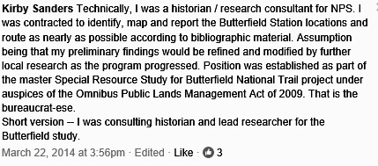

He also went on to state from the study that the only indirect connection to Wells Fargo & Co. was: “Wells Fargo may have run a ‘trunk route’ off Butterfield in LA to San Diego, but it was NOT Butterfield per se.”
In the above statement by Kirby is “Assumption being that my preliminary findings would be refined and modified by further local research as the program progressed.” Since 2009 I have been involved with research that has contributed to the history. A very good article citing that Wells Fargo & Co. never took any physical hand in establishing Butterfield’s Overland Mail Company mail contract No. 12,578 was published in The Smoke Signal, The Tucson Corral of Westerners, Tucson, Arizona, Spring 1968, No. 17, “The Pony Express – The Overland Mail,” by Waddell F. Smith. Waddell was the grandson of William Bradford Waddell, one of the founders of the Pony Express.

Notes:

J. [I.] C. Wood [Woods], Superintendent, REPORT TO HON. A. V. BROWN, POSTMASTER GENERAL, ON THE OPENING AND PRESENT CONDITION OF THE UNITED STATES OVERLAND MAIL ROUTE BETWEEN SAN ANTONIO, TEXAS, AND SAN DIEGO, CALIFORNIA, Washington, D. C., March—, 1858, p. 2.
www.findagrave.com/memorial/28514489
The Arizona Republican, January 9, 1911.
Ibid, Woods, Report to Hon. A. V. Brown.
The Washington Union, Washington D. C., January 28, 1859, “The Escape of Silas St. John.”
New York, New York City Marriage Records, 1829-1940, FamilySearch (https://familysearch.org/ark:61903/), Silas St. John and Julia A. C. Cook, 18 Apr., 1861. Civil War Registration 1863. Clarksville Weekly Chronicle, Tennessee, June 15, 1878. The Cincinnati Daily Star, March 8, 1880.
Weekly Journal Miner, Prescott, AZ, February 1, 1911.
Historic Survey, Reported by Robert Hostick, Duehn-St. John Residence, 4720 Kensington Drive, San Diego, California.
www.findagrave.com/memorial/28514489

